LET LIFESTYLE BE THY MEDICINE
LET MEDICINE BE THY LIFESTYLE
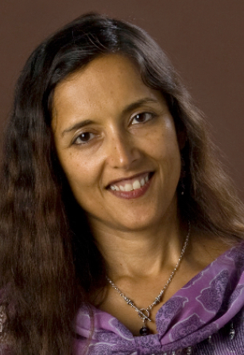
With over 25 years of experience, Dr. Mitra Ray has helped people achieve remarkable success in looking and feeling better.
Dr. Ray received her Bachelors of Science at Cornell University and her PhD from Stanford Medical School. She is the recipient of many NIH grants and the Young Investigator Award from the Federation of American Societies in Experimental Biology. Her research has been published in such prestigious journals as Science, Proceedings of the National Academy of Sciences and the Journal of Cell Biology. Audiences in 4 continents have enjoyed her award winning books, audios and lectures on health, beauty and longevity. Her mission and commitment is to educate and inspire people about how plant-based, whole foods create simple, sustainable beauty and vitality.
Her latest book, Do You Have the Guts to Be Beautiful was highlighted in the March 2013 issue of Women’s Health magazine. www.drmitraray.com.
Come and learn more about:
SIMPLE | SUSTAINABLE | BEAUTY | VITALITY

Join us Friday, Sept. 20, 7:00-8:00pm
(doors open at 6:30 pm)
Junior League of Tucson
2099 E. River Rd, 85718
RSVP: Ginger 520-326-5555, Jeff 419-4143
nutritionwithginger@gmail.com OR wellnesswithjeff@gmail.com

